**Designing a 9-channel relay board**

|  |  |
| --- | --- |
| Author | Martijn Guilliams |

Content

1 Introduction 1

2 Material and methods 1

2.1 Materials 1

2.2 Methods 3

3 Results 4

3.1 Function 4

3.1.1 Short overview 4

3.1.2 Function 4

3.2 Design 5

3.2.1 PCB 5

3.2.2 Finalized product 5

4 Discussion 6

5 Reference List 6

# Introduction

This project is about designing a 9-channel relay board. The main parts of the board are 9 buttons, 9 relays and an LCD. With the press of a button, a relay can be switched on or off. The state of the relay will then be displayed on the LCD. The decision to build this came to me particularly because of the relays. Relays can be useful in many other projects. In chapter 2 is a component list and the methods I used. The result of this project can be seen in chapter 3. In chapter 4 are the difficulties that I encountered.

# Material and methods

## Materials

I searched all the components from the article. If there was that exact component with the right footprint in Altium Designer then I would you that. If there wasn’t an identical component, I searched for another with the same specifications. Price was not of the essence for all the small and mass-produced components like resistors, those only costs a few cents. The components in table 1 with index 1 through 7 are all resistors that were picked because they provide the same specifications and already had a footprint in Altium Designer and are mass-produced. Index 8 through 10 are transistors with the same specifications and their delivery time is very short. On Index 26 is the heatsink for the IC MC7805CTG. This heatsink is merely different in its design. But on the contrary to the heatsink from the article is that this one is available. The LCD has a different colour but the same specifications and better price. All the remaining components are exactly the same as in the article. Most of the components were bought on [Digikey](https://www.digikey.be/nl). They had the cheapest and most available components with the shortest delivery date. Some items were not available on Digikey. The second-best option for this situation was [Sinuss](https://sinuss.be/).

In table 1 is a list of all the components used in this project. There is also a column for the prices and the supplier of the component.

Tabel 1 component list



## Methods

To test if the LCD could fit the preferred socket and if it had the same pin-out, I searched the datasheet of the display. The datasheet shows that it has the exact pinout. To be certain, it was also test-fitted into the socket.

Figure 1 Schematic representation

# Results

## Function

### Short overview

The idea is that the relays can be switched by pressing the respective button. If button one is pressed the microcontroller will then switch the state of relay number one. The microcontroller will also switch the state that is displayed on the LCD. This process is the same for every button.

### Function

A 12V power adapter is needed to power this board. This adapter has to be connected to TB1 (the barrel plug). The 12V powers the relays, IC3 and will also be converted to 5V through IC1. IC1 is a linear voltage regulator that can regulate a voltage from 10V to 35V into 5V 1A. 5V is needed to power the LCD, IC2, and MOD1. MOD1 is only used to program IC2 but this can also be done directly if IC2 is not soldered in. IC2 is an 8-bit microcontroller that reads the state of the buttons. The buttons use pull-up resistors that are connected to the 5V circuit. This means that if the button is pressed the signal will be low and if it is not pressed then it will be high. If a button is pressed, IC2 will send a 3,3V signal to IC3 on the correct pin. IC3 is a Darlington transistor array. It has eight NPN Darlington pairs that have high-voltage outputs. If a signal is received it will switch the correct relay. IC2 also controls the LCD. It displays the state of all the relays. The backlight of the LCD can be controlled by turning VR1. VR1 is a potentiometer and controls the ongoing voltage.

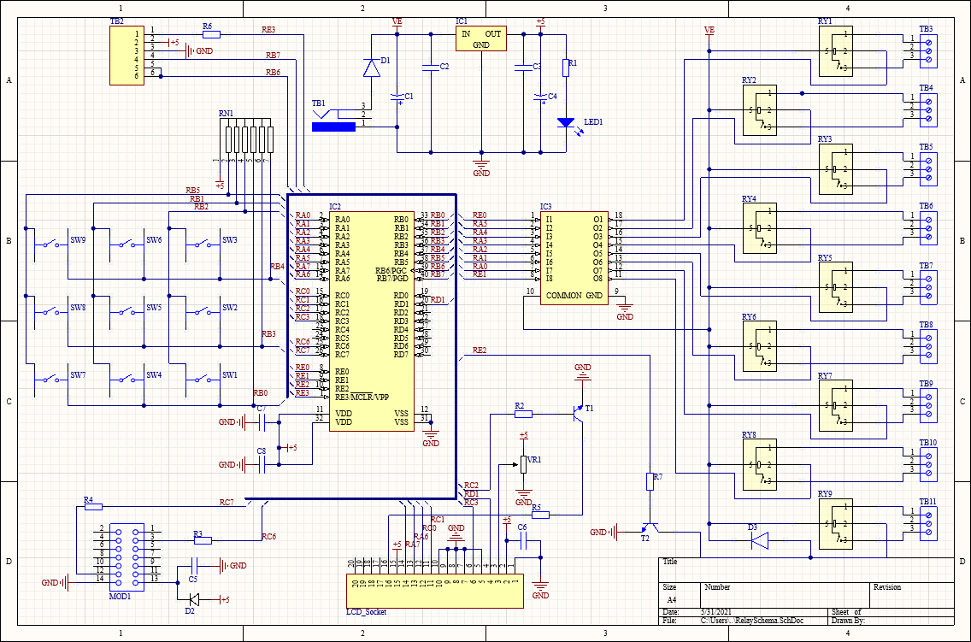Figure 2 shows the electrical schematic that has been used for the PCB.

Figure 2 electrical schematic

## Design

### PCB

Figure 3 show the PCB design that has been used in this project.

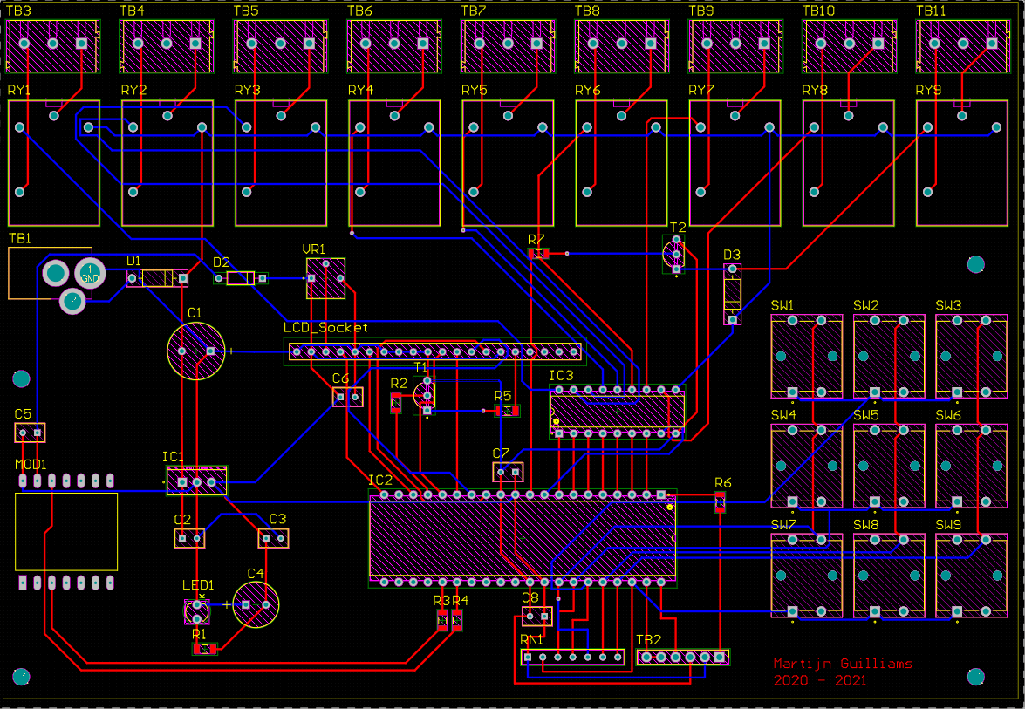

Figure 3 PCB design

### Finalized product

Figure 4 shows the finalized product.

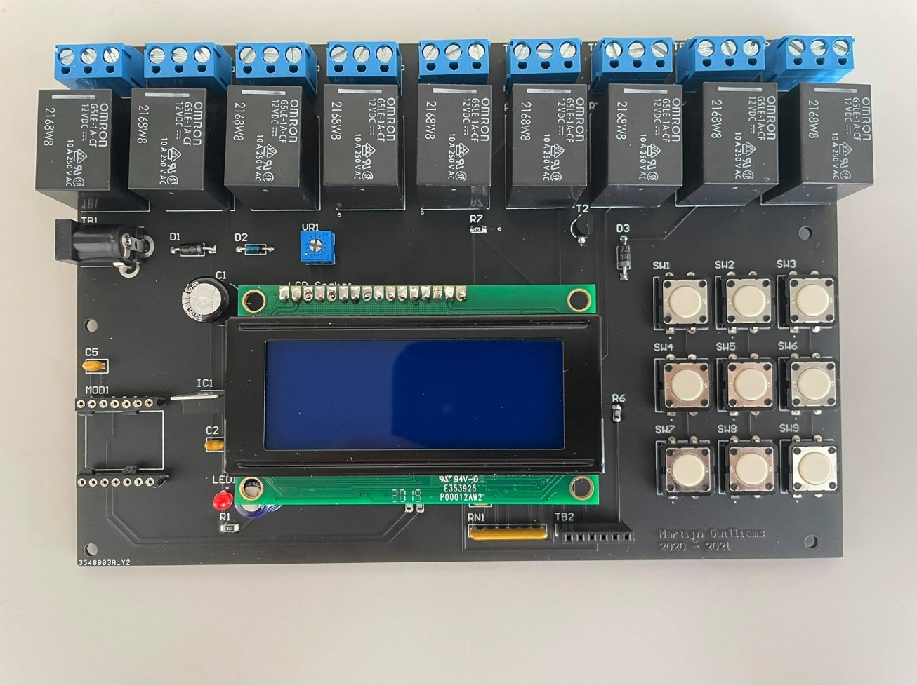

Figure 4 finalized product

# Discussion

There was a problem with the placement of the LCD. The order contained an IC socket but another larger socket was needed. The IC socket was already placed when it was noticed therefore another solution was needed. Luckily we found a pin with a smaller side that fitted the IC socket and the other bigger side that fitted for the LCD.

There was also a minor problem or inconvenience with the footprints of T1 and T2. The spacing of the holes was too close. This meant that the footprint had to be altered or using another footprint. In a few seconds, another footprint was found and then used. I then later had to bend the legs of the transistor so it could fit.

Except for those problems the PCB design went great. There was a bit of being too focused on the PCB and not the other also important tasks of this project like the case design. There is still time for that but not as much I had hoped.

# Reference List

|  |  |
| --- | --- |
| [1] | M. Displays, „farnell,” 31 October 2016. [Online]. Available: http://www.farnell.com/datasheets/2825766.pdf. [Geopend 3 April 2021]. |
| [2] | E. Labs, „elektormagazine,” 11 January 2019. [Online]. Available: https://www.elektormagazine.com/labs/9-channel-relay-control-board-with-pc-interface-130549#&gid=1&pid=4. [Geopend 2 April 2021]. |